**DATA ANALYSIS PROJECT**

## **Analysis A Report**

import numpy as np

import matplotlib.pyplot as plt

import seaborn as sns

import pandas as pd

## 1.Perform general Data analysis ?

* The data set which I performed analysis is taken in the form csv file taken from available sources.
* I find some missing values and I filled those missing with appropriate values.
* The dataset which I performed analysis has 371528 rows × 20 columns

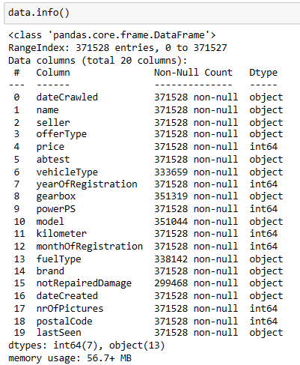

## 2) Can you tell me the Distribution of Vehicles based on Year of Registration with the help of a plot ?

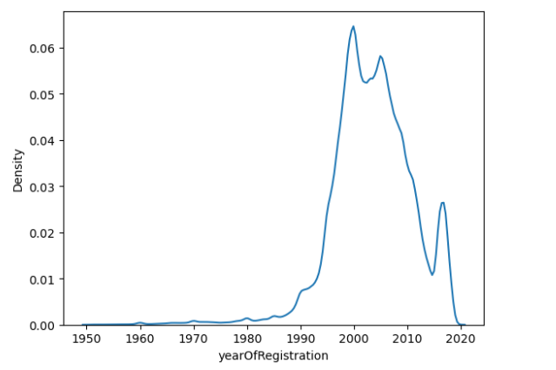

* From this which I concluded that majority of vehicles distributed in the years between 1997-2000.
* And least happened in between 1950-1959.

## 3) Create a plot based on the Variation of the price range by the vehicle type ?

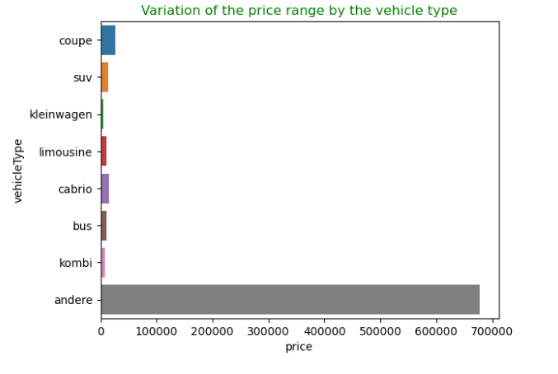

* From this I concluded that huge price variation seen for “andere” which is one of the vehicle type.
* Least for “kleinwagen”.

## 4) Find out Total count of vehicles by type available on ebay for sale.As well as create a visualization for the client ?

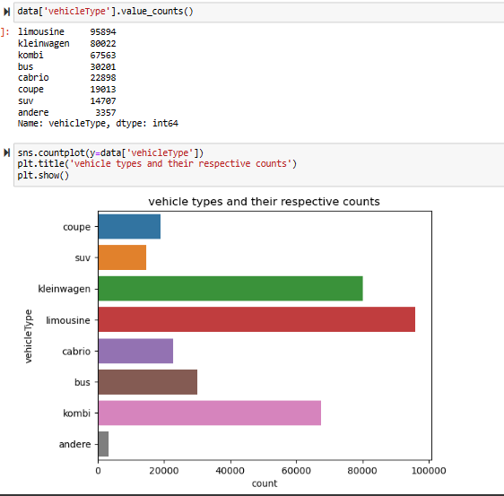

* From this I can say that “limousine” has huge availability for sale in ebay.
* Least is “andere”.

## 5) Is there any relationship between dollar_price and kilometer? (Explain with appropriate analysis) ?

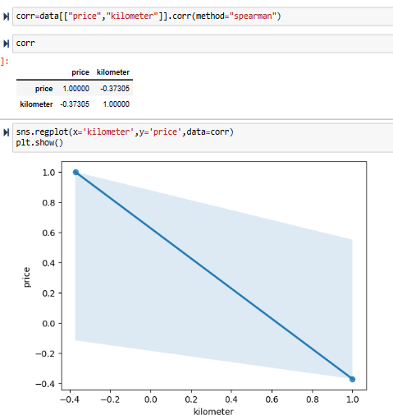

* We concluded from the above observations there is negative monotonic relation between dollar_price and kilometer.

## 